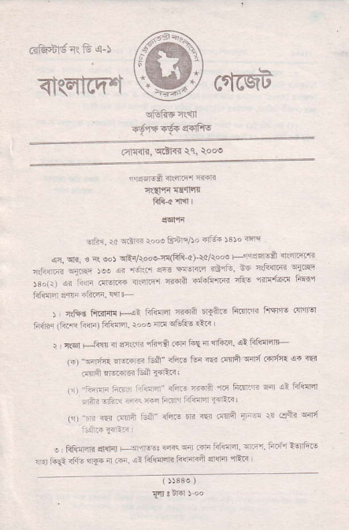
_{cdfqdda".} fu d-)
_{<Rqtrqn} c{cqA ^{qltRE} rslr
x{#ffi6fls
_{c41{<l?,} ^{qdRr} il. tooo
!rAi. _{ra} {i4 r.'e _{FFrtso 41iti )3 !o} l'rt
_{<c} ^{qli.} ! _{* oo)} qRrA@er!(fi1i"4)_\d/iaoo _{+i'rr-A} <t:miE _{.liiar} ^{qTr} _{)!o {i} ^{'r'nr} o% rft@ <illrt. _{6+ c6qta.} s{b!t ^{:r"t.r} _{"u r,,r' ro--"} u,-r.o'r _{{iarn} -i'Iffi _{nA!} ^{'rfrl@} ft'5f _{i{{F."F} r:, rF. !"i+
i r&6 _{ftrff{ r-!-} F.fdH Ttril tEfta! _{ftfl''R} riF'F cn'rFr fn,(Fr (h.F _{iirn) ffisr. r."o;m} !,trs ri.n
J,c$rF ft4 < nllrr ift€ .n _{riE} ir _{{i?'i.} ^{qi} Fiq4|F (a) "ffiF ffi F"€] _{31n.! tun @ csnt} *i.tFia: {a iRtr @rA i@B ^{tui} rxii,
_{1.r} ?ti!F _{i:ri:} i.i<"rr' _{i'+} ^{'FFi} _{rn Ficri} 5a ii Fturm : Ar _{!li-} .n.i r+- FrH drfrr fl-e,
(, ₎ ^{_rn} r rm.'r kili nii.s m rEr d:nff _{1]} 'r !r cfr'
! Rllir4n dlqd _{+rnrFr iR} ^{q'rr} _{rF trirFr'} ^{qFr.} f'rnt a6riR! I ar tu91 3i,1- _{{rf. a Fi.} e: trffi lisFil $?rir n-.i
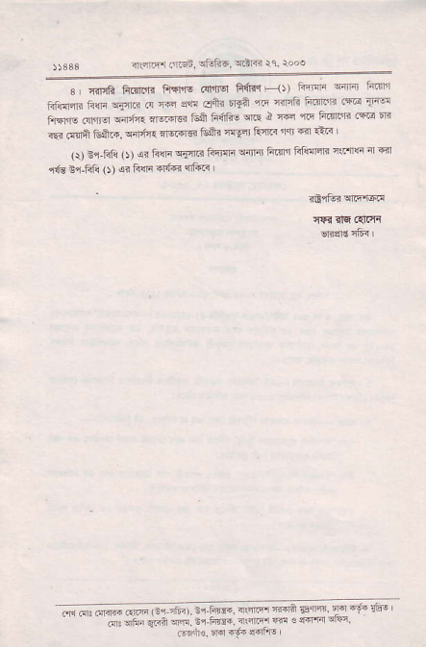
{t4fF4 _{ffiEn, !fufi6,} ^{qdR} $. rooo
_{s r cE ftrnjjr ffTns} ^{(d'sq} 1i6fi _{F} _{, _{fiElri} ^{qriar} fti{l1 ^{jiJinfir} _{liqF} ^{qflc} .{ {ir slr _{dft} 6fJA 1lt {iFG _{li'{('l{} ^{(@} T@ _{fltN @lrrq} ^{q4r;f{} EFi.l6{ _{toA 64frs} sriE i TF rr. tn,qra 16! 'r? _{iEr} ^{({na} _{Gft.,} ^{qilj"4{} nqal6 &ir. fga F{r< rqi a] €n L
_{Q) B! lili} (t _{si Fn} ^{qfln} _{fi5j{i} ^{q{i{} Frfi Flillqlr _{r\i'trq} ^{;n} F{r {{B ^{ir-Rf{} _{O)} 4r Fllr _{${d} 'rft<
_{""; ffi (!ra!'} ^{-1"-.} -jrr _{{.'f'"<F"} ' ?a;ia' _{drqft. Eir4} d !nF@.4!F

